(1). Stable Diffusion WebUI 介面說明

* Prompt :我們想要看到的內容
* Negative Prompt : 我們不想看到的內容
* Sampling Method：取樣的方法，會影響照片產生的細節
* Sampling Steps：取樣次數，次數越高，花費的時間越久，細節當然也越好
* Restore faces：修正臉部問題
* Hires.fix：修正高取樣的情況下，背景變得很奇怪的狀況
* Width：圖片的寬度
* Height：圖片的高度
* Batch count：每一次算圖總共產生幾張圖片
* Batch size：同時算幾張圖片
* CFG Scale：個值越低的話，AI 產生的圖可能不一定會照要求
* Seed：種子值，可以看作是隨意值，在同樣的參數下，這個值不同就會產生不同的樣子

(2). 實際操作:

* Prompt :  
  masterpiece, best quality, 4k, photo, realistic, 1girl, 17yo, (short white color button shirt, black skirt, school uniform open slightly, tug), (natural breast), (full body), (sexy pose), soft lips, black glasses, (looking at camera:0.6), pale skin, (brown hair), (detailed eyes:1.3), (ponytail floating hair NovaFrogStyle:1.2), depth of field, blushing, ashamed, (smile:1.1), black eyes, (random color bar), bangs
* Negative Prompt :  
  paintings, sketches, (worst quality:2), (low quality:2), (normal quality:2), lowres, normal quality, ((monochrome)), ((grayscale)), skin spots, acnes, skin blemishes, age spot, (outdoor:1.6), manboobs, backlight,(ugly:1.331), (duplicate:1.331), (morbid:1.21), (mutilated:1.21), (tranny:1.331), mutated hands, (poorly drawn hands:1.331), blurry, (bad anatomy:1.21), (bad proportions:1.331), extra limbs, (disfigured:1.331), (more than 2 nipples:1.331), (missing arms:1.331), (extra legs:1.331), (fused fingers:1.61051), (too many fingers:1.61051), (unclear eyes:1.331), bad hands, missing fingers, extra digit, (futa:1.1), bad body, NG_DeepNegative_V1_75T,pubic hair, glans

[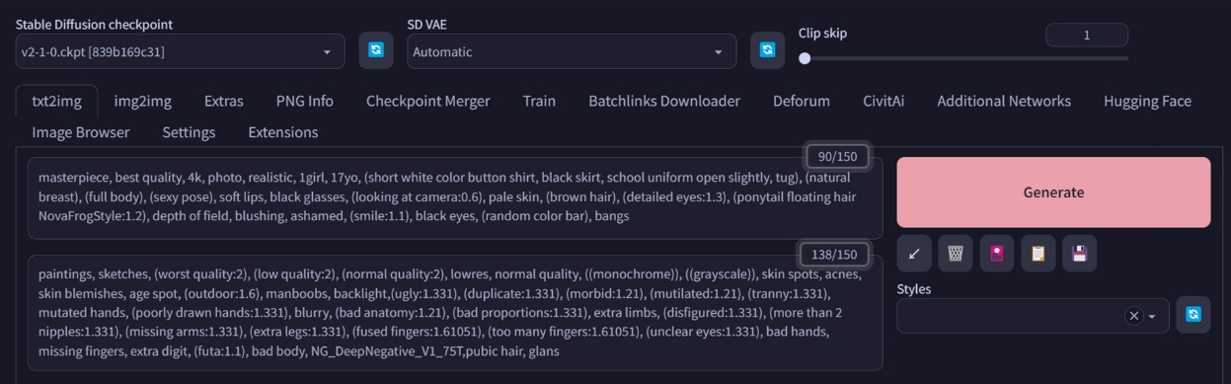](https://user-images.githubusercontent.com/131600128/233847099-043255e2-4386-439a-bec6-896abbf3ed45.jpg)

* 設定算圖方法、次數、大小與張數

[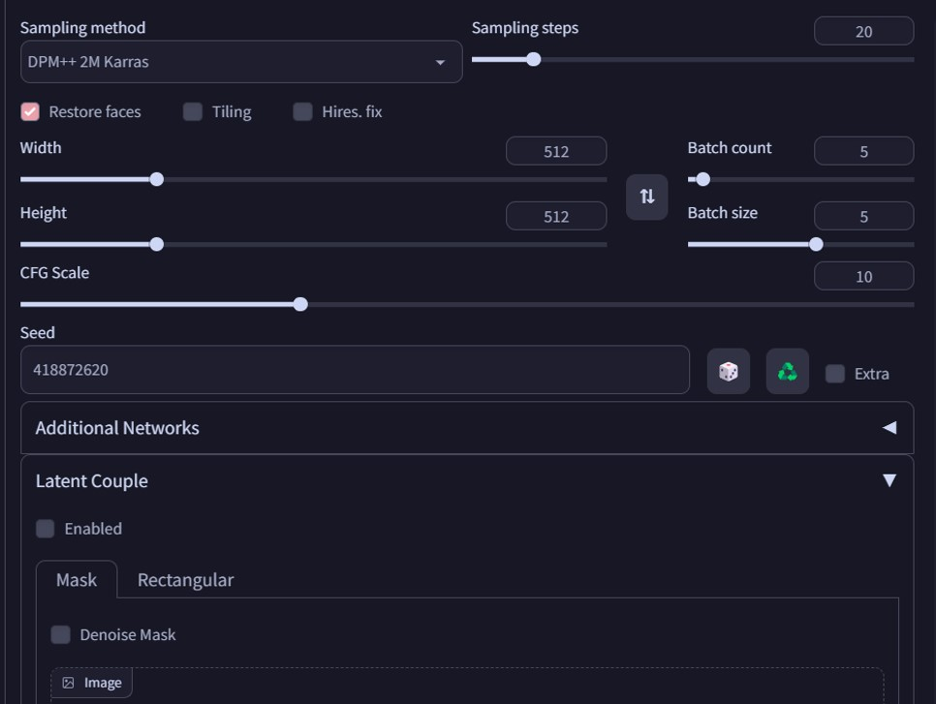](https://user-images.githubusercontent.com/131600128/233847164-77de2d2e-0bc2-42ac-8a8a-6b22054b9fd3.jpg)

* 之後就會生成AI圖片

[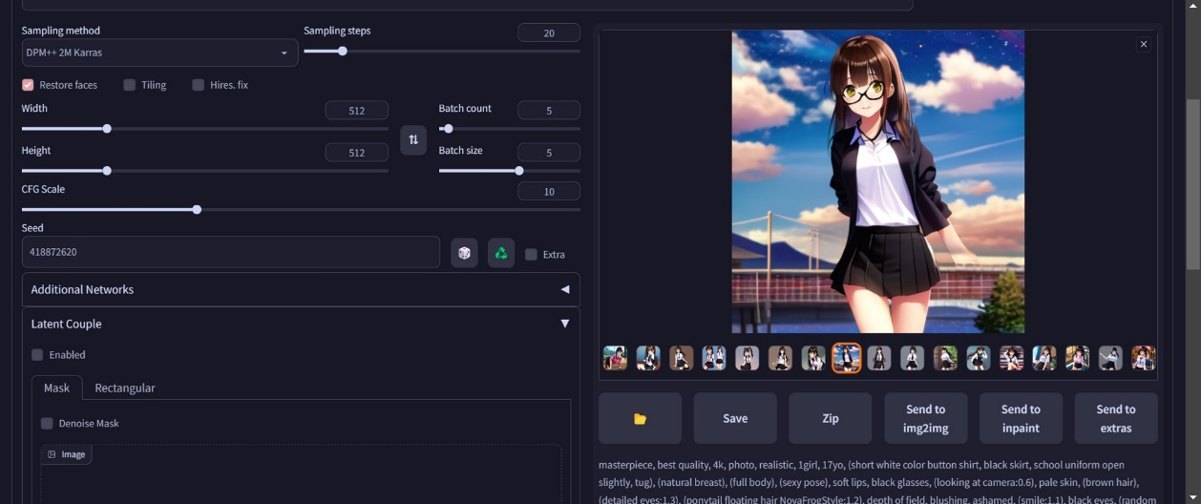](https://user-images.githubusercontent.com/131600128/233847187-82093ab5-3e9d-445a-bfd6-a7d3f75ea09e.jpg)

[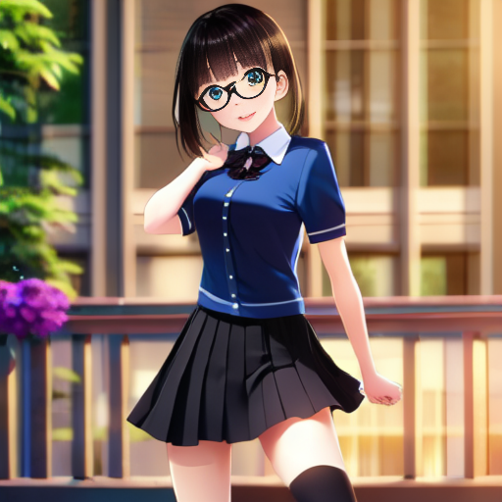](https://user-images.githubusercontent.com/131600128/233847204-3b34b299-c2f8-410b-8d6d-17d2a7b80a92.png)  
P.S 依照不同描述與參數，會有不同的結果~